2026-2027

Name of the Event: MHU MUSHROOM RESEARCH CENTRE Murthal Sonipat
Organised by: Department of Botany, Hansraj College, University of Delhi
Date: 17th September 2026
Time: 10:00 PM onwards
Venue: MHU MUSHROOM RESEARCH CENTRE Murthal Sonipat, Haryana
Name of Coordinator: Dr. Arti Mishra
Name of Co-cordinators (s): Dr. Urvashi Tomar, Dr. S. Sachin

Event Description
The 41 students and 3 faculty members from Hansraj College, Delhi University visited the Regional Mushroom Research Centre (RRC-MHU), Murthal, Sonipat, Haryana on 17th September 2026 from 11:00 a.m. to 2:00 p.m. The visit began with an orientation session introducing mushroom biology and cultivation practices, followed by a tour of the laboratories where students observed spawn production and compost testing. In the controlled cropping rooms and composting yards, they witnessed mechanized facilities and seasonal cultivation methods, gaining valuable insights into commercial-scale mushroom farming. A specially arranged video presentation on mushroom production further enriched their understanding by providing a step-by-step visual overview of cultivation techniques and modern practices.
Students learnt the process of substrate preparation and spawn inoculation, bridging theoretical knowledge with viewing practical application. The group also visited a Dragon fruit garden along with Turmeric plantation, where they learned about cultivation practices, plant management, and the economic potential of this emerging horticultural crop. Observing the field layout and fruiting stages gave them exposure to diversification in agriculture.
A highlight of the visit was the interaction with Dr. Ajay Singh, Scientist Incharge, HAIC Agro R&D Centre, Murthal, who addressed the students with his guidance, support, and efforts in making the educational visit meaningful and memorable. His insights into mushroom research, agribusiness opportunities, and sustainable cultivation practices left a lasting impression on the students. Overall, the visit provided a holistic learning experience, combining exposure to mushroom research, dragon fruit cultivation, multimedia learning, and expert guidance. It not only enhanced students’ academic understanding but also inspired them to explore innovative avenues in sustainable agriculture and agribusiness.
Geo-tagged pictures:
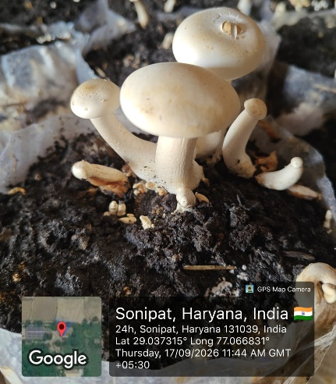
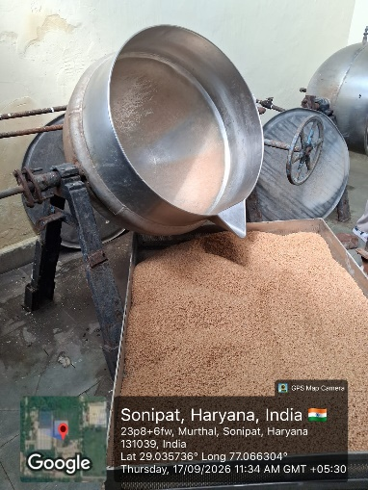
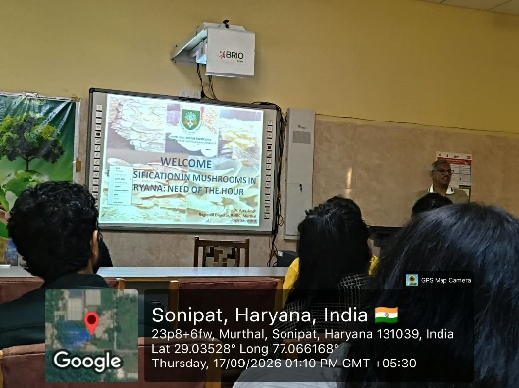
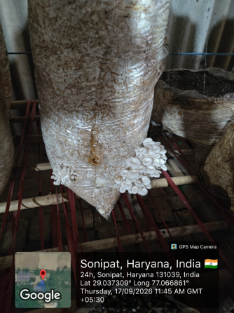
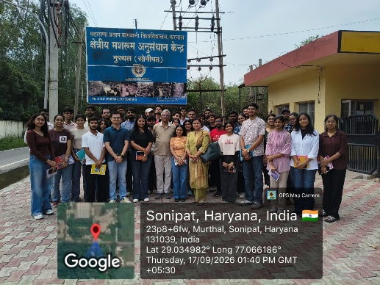
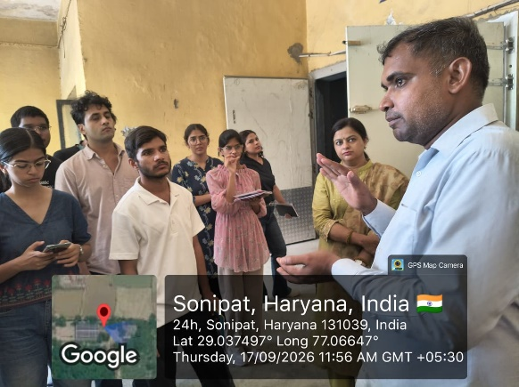

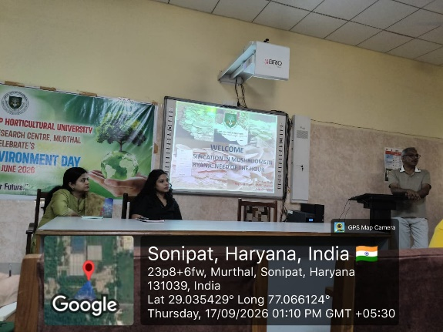

Attendance list:

